CivicSense: Government Grievance and Public Sentiment Analysis System

Dr N SUNANDA
Department of Computer Science and Engineering
Koneru Lakshmaiah Education Foundation
Hyderabad, India
drnsunanda@klh.edu.in
Saranya Suryadevara
Department of Computer Science and Engineering
Koneru Lakshmaiah Education Foundation
Hyderabad, India
suryadevarasaisaranya@gmail.com
Batta Chetna Chaudhary
Department of Computer Science and Engineering
Koneru Lakshmaiah Education Foundation
Hyderabad, India
chetnab1204@gmail.com

Abstract—Government organizations receive large volumes of citizen grievances related to public services such as roads, water supply, electricity, healthcare, education, and transportation. Manually analyzing these complaints is difficult because grievance data may contain unstructured text, missing values, duplicate records, and unnecessary information. This paper proposes CivicSense, a Government Grievance and Public Sentiment Analysis System that combines data analytics, Natural Language Processing, machine learning, and visualization to analyze citizen complaints. The proposed system performs data cleaning, text preprocessing, complaint classification, sentiment analysis, and trend analysis. Complaints are organized into public-service categories, while sentiment analysis identifies positive, negative, and neutral feedback. The analyzed information is presented through an interactive Streamlit dashboard containing grievance statistics, complaint categories, sentiment distributions, frequently reported issues, and complaint trends. The proposed system aims to transform raw citizen feedback into structured and understandable insights that can support the analysis of public-service issues.
Keywords—Government grievances, Natural Language Processing, sentiment analysis, machine learning, complaint classification, trend analysis, data analytics, Streamlit

Introduction (Heading 1)
Government organizations receive a large number of grievances and complaints from citizens regarding public services such as roads, water supply, electricity, healthcare, education, and transportation. These grievances contain valuable information about the problems experienced by citizens and can provide an indication of the quality of public services. However, grievance records are often available as large collections of textual data, making it difficult to manually examine and organize every complaint. Your project specifically identifies these public-service categories as the areas CivicSense is intended to analyze.
The major challenge is not merely collecting citizen grievances but extracting meaningful patterns from them. A collection of raw complaints does not directly indicate which public-service issues are most frequently reported, whether citizens are generally satisfied or dissatisfied, or how complaint patterns change over time. In addition, grievance data may contain missing values, duplicate records, and unnecessary information that can affect subsequent analysis. Therefore, an effective approach is required to clean the data and transform unstructured complaint text into information that can be systematically analyzed. The proposed project explicitly includes data cleaning for missing values, duplicate records, and unnecessary information.
Since citizen grievances are primarily expressed through natural language, Natural Language Processing (NLP) can be used to process complaint text and extract meaningful information. Complaint classification can organize grievances into categories such as roads, water, electricity, healthcare, education, and transportation. Sentiment analysis can additionally determine whether the expressed feedback is positive, negative, or neutral. Machine learning can be incorporated to train and evaluate a basic classification model using a public sentiment dataset before applying the learned model to relevant complaint data. These capabilities are central to the CivicSense proposal.
To address these challenges, this paper proposes CivicSense, a Government Grievance and Public Sentiment Analysis System that combines data analytics, NLP, machine learning, and visualization. The system follows a processing pipeline consisting of grievance data collection, data cleaning, text preprocessing, complaint classification, sentiment analysis, trend analysis, and visualization. The analyzed information is presented through an interactive Streamlit dashboard containing statistics, complaint categories, sentiment distributions, frequently reported issues, and complaint trends.
The primary objective of CivicSense is to provide a practical data-driven approach for understanding government grievances and public sentiment. The system aims to identify frequently reported public-service issues, determine sentiment patterns in citizen feedback, analyze changes in complaints over time, and provide an accessible visual representation of the results. By integrating data preprocessing, NLP, machine learning, and visualization, the proposed system seeks to transform raw citizen feedback into structured and understandable insight

RELATED WORK

Grievance Redressal and Sentiment Analysis
Natural Language Processing has been increasingly applied to government grievance and citizen-feedback systems to extract useful information from large volumes of unstructured text. Existing research has demonstrated that sentiment analysis can help identify whether citizens express positive or negative opinions regarding public services. Rosa et al. developed and deployed a sentiment analysis system for citizen feedback in Goiás, Brazil, using NLP and machine learning to automatically classify feedback related to public services [1]. Such approaches demonstrate the potential of automated sentiment classification for supporting public-service evaluation.

Citizen Feedback Analysis Using NLP
Sarvestani proposed an NLP-based framework for analyzing citizen feedback from U.K. government mobile applications, including HMRC, NHS, and GOV ID CHECK [2]. The study combined sentiment analysis with topic modelling to identify citizens' opinions and the major issues discussed in application reviews. The work demonstrated that NLP can be used to transform large amounts of unstructured citizen feedback into information that can help identify service-related problems and areas requiring improvement [2].

PROPOSED SYSTEM
The proposed CivicSense system is designed to transform raw government grievance data into structured and understandable information using data analytics, Natural Language Processing (NLP), machine learning, and visualization. The overall workflow consists of data collection, data cleaning, text preprocessing, complaint classification, sentiment analysis, trend analysis, and interactive visualization.

System Architecture
CivicSense follows a sequential data-processing architecture in which raw grievance records are first collected and cleaned before being processed using NLP and machine-learning techniques. The processed complaints are classified according to public-service categories, followed by sentiment analysis to determine the nature of citizen feedback. Trend analysis is then performed to identify changes in complaint patterns over time. Finally, the analyzed information is presented through an interactive Streamlit dashboard.

Data Collection
- The first stage of CivicSense is the collection of grievance data from publicly available government sources. The proposed project identifies the CPGRAMS/Government Grievance Dataset as the primary source of grievance information. A separate public sentiment dataset containing text and corresponding positive, negative, and neutral labels is used for developing and evaluating the sentiment classification model.
- The collected grievance records may contain complaint descriptions along with other relevant information required for analysis. The data is subsequently passed to the preprocessing stage before performing NLP and machine-learning operations.

Data Preprocessing
- Raw grievance data may contain missing values, duplicate records, and unnecessary information. Therefore, preprocessing is performed to improve the quality and consistency of the dataset before analysis.
- The preprocessing stage consists of:
- Handling missing values.
- Removing duplicate records.
- Removing unnecessary information.
- Cleaning complaint text.
- Preparing text for NLP processing.
- Converting the cleaned data into a suitable format for subsequent analysis.
- This stage is important because the quality of the input data can influence the results of complaint classification and sentiment analysis.

Complaint Classification
- After preprocessing, the complaint text is analyzed and organized according to the type of public service involved. CivicSense considers the following major categories:
- Roads
- Water Supply
- Electricity
- Healthcare
- Education
- Transportation
- Other Public Services
- Complaint classification allows large collections of grievances to be grouped into meaningful service categories. This makes it easier to identify which areas generate a greater number of complaints and supports further category-wise analysis.

METHODOLOGY
The methodology of CivicSense consists of a sequence of data processing and analysis steps that transform raw government grievance records into structured information. The process includes data acquisition, data cleaning, natural language processing, complaint classification, sentiment classification, trend analysis, and visualization. Each stage prepares the output required by the subsequent stage, resulting in an integrated workflow for analyzing citizen grievances.

Data Acquisition

The first stage involves collecting the datasets required for grievance and sentiment analysis. The primary grievance data is obtained from publicly available government grievance sources. In addition, a public sentiment dataset containing textual information and corresponding sentiment labels is used for developing and evaluating the sentiment classification model.

The collected data is loaded into the Python environment and examined to identify the relevant attributes required for analysis. Complaint descriptions and other useful fields are retained, while information that is not required for the analysis is considered for removal during preprocessing.

Data Cleaning
Raw grievance datasets may contain missing values, duplicate records, inconsistent entries, and unnecessary information. Therefore, data cleaning is performed before applying NLP and machine-learning techniques.
The cleaning process includes identifying and handling missing values, removing duplicate records, eliminating unnecessary attributes, and preparing the complaint records for further processing. This step improves the consistency of the dataset and reduces the possibility of inaccurate analysis caused by incomplete or repeated records.

Text Preprocessing

The complaint descriptions are processed using Natural Language Processing techniques to prepare the textual information for classification and sentiment analysis. The text is cleaned to remove irrelevant characters and information and is converted into a consistent representation.

Depending on the requirements of the dataset, preprocessing may include tokenization, removal of unnecessary words or symbols, normalization of text, and other standard text-cleaning operations. The resulting processed text is used as input for subsequent feature extraction and classification tasks.

Feature Extarction

The processed textual data must be represented in a numerical form before it can be provided to a machine-learning model. Feature extraction converts the textual information into numerical features that represent relevant characteristics of the complaint text.

The selected feature-extraction method is applied to the preprocessed complaint text, and the resulting feature representation is provided to the classification model. The exact technique used is determined by the implementation and experimental setup of CivicSense.

Sentiment Classification

Sentiment classification is performed to determine the nature of the opinion expressed in a citizen's complaint. CivicSense considers three sentiment classes: positive, negative, and neutral.

A machine-learning classification model is trained and evaluated using the public sentiment dataset. After the model is developed, it can be applied to relevant grievance text to determine the sentiment associated with citizen feedback. The resulting sentiment labels can be analyzed together with complaint categories to understand the relationship between service-related issues and public sentiment.

Trend Analysis

Trend analysis is performed on the processed grievance records to identify changes in complaint patterns over time. The complaints are grouped according to relevant time periods and analyzed using their categories and sentiment classifications.

This stage enables CivicSense to identify variations in complaint frequency, recurring service-related issues, and changes in sentiment patterns over different periods. The resulting trends provide an additional perspective for understanding citizen feedback beyond individual complaints.

Visualization and Dashboard

The final stage involves presenting the processed information through an interactive Streamlit dashboard. Visualization techniques are used to represent complaint statistics, category distributions, sentiment distributions, frequently reported issues, and temporal trends.

The dashboard provides interactive filters and graphical representations that allow users to explore the analyzed grievance data. The combination of data analytics and visualization makes the results easier to interpret and provides a user-friendly interface for examining public-service grievance patterns.

IMPLEMENTATION
The CivicSense system is implemented using Python-based data analysis, Natural Language Processing, machine learning, and visualization technologies. The implementation follows the methodology described in the previous section, beginning with dataset loading and preprocessing and continuing through complaint classification, sentiment analysis, trend analysis, and dashboard development.

Development Environment

Python is used as the primary programming language for implementing the CivicSense system. Python provides libraries for data manipulation, numerical computation, machine learning, natural language processing, and visualization. The main technologies used in the implementation include Pandas, NumPy, Scikit-learn, Matplotlib, Plotly, and Streamlit.

The system is organized as a data-processing pipeline so that the output generated at one stage can be used as input for the next stage.

Data Processing Using Python
Pandas is used for loading, organizing, cleaning, and manipulating the grievance datasets. The data is represented using structured data frames, which allow individual records and attributes to be examined efficiently.
NumPy is used for numerical operations required during data processing and analysis. The combination of Pandas and NumPy provides the basic data-processing environment required for handling the grievance datasets.
The implementation includes operations for identifying missing values, removing duplicate records, selecting relevant attributes, and preparing the data for subsequent text analysis.

NLP and Machine Learning Implementation

The complaint descriptions are processed using Natural Language Processing techniques to prepare textual information for analysis. The processed text is converted into a suitable feature representation before being supplied to the machine-learning model.

Scikit-learn is used for implementing the machine-learning components of the system. A public sentiment dataset containing textual data and sentiment labels is used for training and evaluating the selected classification model. The trained model is subsequently applied to relevant grievance records for sentiment classification.

Complaint and Sentiment Analysis

The complaint classification component organizes grievance records into predefined public-service categories, including roads, water supply, electricity, healthcare, education, transportation, and other public services.

The sentiment analysis component assigns sentiment labels to the relevant complaint text. The three sentiment categories considered by CivicSense are positive, negative, and neutral.

The combination of complaint category and sentiment information allows the system to examine both the type of public-service issue and the sentiment expressed by citizens.

Data Visualization

Matplotlib and Plotly are used to create graphical representations of the analyzed data. Visualizations can represent complaint-category distributions, sentiment distributions, frequently reported issues, and changes in complaint patterns over time.

The visual outputs provide a clearer representation of the information obtained from the processed grievance records and make it easier to identify patterns within the data.

Streamlit Dashboard

Streamlit is used to develop the interactive user interface for CivicSense. The dashboard integrates the outputs of the data-processing and analysis stages into a single interface.

The dashboard is designed to display overall grievance statistics, complaint categories, sentiment distributions, frequently reported issues, and complaint trends. Interactive filters allow users to examine specific portions of the dataset and explore the available analytical information.

The dashboard therefore provides the final presentation layer of the CivicSense system, connecting the underlying data-processing pipeline with an accessible visual interface.

RESULTS AND DISCUSSION

The performance of CivicSense was evaluated using the supplied demonstration grievance dataset. The experiments examined two supervised text-classification tasks: (i) complaint-category classification and (ii) sentiment classification. Logistic Regression was used as the primary classifier, while Multinomial Naive Bayes was evaluated as a baseline using the same training and testing partitions.
A. Dataset Summary
The supplied file, demo_grievances.csv, contains 80 grievance records and nine attributes: complaint ID, complaint text, category, sentiment, date, ward or region, department, status, and urgency. The dataset contains eight complaint categories with 10 records in each category. The sentiment distribution consists of 39 negative, 28 positive, and 13 neutral records. Inspection of this file identified no missing cells and no exact duplicate rows. The data covers the period from 1 August 2026 to 24 September 2026.
Dataset characteristic | Observed value
Total records | 80
Number of attributes | 9
Missing cells | 0
Exact duplicate rows | 0
Complaint categories | 8 (10 records per category)
Negative sentiment | 39
Positive sentiment | 28
Neutral sentiment | 13
Date range | 1 August 2026 – 24 September 2026
The dataset is balanced across the eight complaint categories, but the sentiment labels are not equally distributed. In particular, neutral complaints represent the smallest sentiment group. This difference is relevant when interpreting class-wise performance.
B. Experimental Setup
Complaint text was cleaned using the preprocessing function before feature extraction. TF-IDF vectorization was configured to consider unigrams and bigrams, with sublinear term-frequency scaling. The category classifier used a maximum vocabulary size of 1,500 features, whereas the sentiment classifier used 1,200 features. The Logistic Regression models were configured with a maximum of 1,000 iterations, regularization parameter C = 1.5, and balanced class weights. Multinomial Naive Bayes with smoothing parameter alpha = 0.5 was used for baseline comparison.
For both tasks, the dataset was divided into 75% training data and 25% testing data using random_state = 42. Therefore, 60 records were used for training and 20 records for testing. Stratified splitting was applied when class counts permitted. The TF-IDF vectorizer was fitted only on the training partition and then applied to the test partition to avoid information leakage from the test data.
Performance was measured using accuracy, weighted precision, weighted recall, weighted F1-score, macro precision, macro recall, and macro F1-score. Five-fold stratified cross-validation was also performed on the training partition. The same train-test split and TF-IDF feature matrices were used for comparing Logistic Regression and Multinomial Naive Bayes.
C. Complaint Category Classification Results
The complaint-category model classifies each grievance into one of eight public-service categories. Logistic Regression achieved an accuracy of 60.00% and a weighted F1-score of 58.17% on the 20-record test set. Its weighted precision was 64.17%, while weighted recall was 60.00%. The macro F1-score was 58.75%, indicating the average class-wise performance when each category is given equal importance.
Evaluation metric | Logistic Regression | Multinomial Naive Bayes
Accuracy | 60.00% | 55.00%
Weighted precision | 64.17% | Not separately recorded
Weighted recall | 60.00% | Not separately recorded
Weighted F1-score | 58.17% | 53.21%
Macro precision | 62.50% | Not separately recorded
Macro recall | 62.50% | Not separately recorded
Macro F1-score | 58.75% | Not separately recorded
The comparison shows that Logistic Regression performed better than Multinomial Naive Bayes on both reported comparison measures. It improved accuracy by 5 percentage points and weighted F1-score by 5.96 percentage points. This indicates that Logistic Regression was the stronger of the two evaluated classifiers for the supplied category dataset.
The five-fold cross-validation accuracies for the Logistic Regression category model were 41.67%, 50.00%, 75.00%, 75.00%, and 58.33%. The mean cross-validation accuracy was 60.00%, with a standard deviation of 13.33 percentage points. The variation across folds indicates that performance changes depending on the particular training and validation samples, which is expected with a small dataset.
D. Sentiment Classification Results
The sentiment model assigns one of three labels—negative, neutral, or positive—to each complaint. Logistic Regression achieved 55.00% accuracy and a weighted F1-score of 53.97% on the 20-record test set. Weighted precision and weighted recall were 54.17% and 55.00%, respectively. The macro F1-score was 49.93%, which is lower than the weighted F1-score and indicates that performance is less consistent when each sentiment class is considered equally.
Evaluation metric | Logistic Regression | Multinomial Naive Bayes
Accuracy | 55.00% | 50.00%
Weighted precision | 54.17% | Not separately recorded
Weighted recall | 55.00% | Not separately recorded
Weighted F1-score | 53.97% | 43.67%
Macro precision | 52.78% | Not separately recorded
Macro recall | 48.73% | Not separately recorded
Macro F1-score | 49.93% | Not separately recorded
Logistic Regression outperformed Multinomial Naive Bayes in sentiment classification, with a 5 percentage-point improvement in accuracy and a 10.30 percentage-point improvement in weighted F1-score. However, the macro F1-score of 49.93% suggests that the model does not perform equally well across all sentiment labels. The smaller number of neutral examples may contribute to this variation.
The five-fold cross-validation accuracies for sentiment classification were 50.00%, 58.33%, 58.33%, 41.67%, and 66.67%. The mean was 55.00%, with a standard deviation of 8.50 percentage points. These results show moderate variation across folds and should be interpreted cautiously because the complete dataset contains only 80 records.
E. Confusion Matrix Analysis
The confusion matrix provides a class-wise view of correct and incorrect predictions. Rows represent the actual class, while columns represent the predicted class. The diagonal entries correspond to correct predictions; off-diagonal entries represent misclassifications.
For complaint-category classification, the model correctly classified 12 of the 20 test records. The remaining eight records were assigned to a different category. The errors were distributed across several categories rather than being limited to one single class. This suggests that some complaint descriptions contain overlapping vocabulary or insufficient context to distinguish closely related public-service domains.
Actual category (row) / Predicted category (column) | Drainage / Sewage | Education | Electricity | Healthcare | Other Public Services | Roads | Transportation | Water Supply
Drainage / Sewage | 2 | 0 | 0 | 0 | 0 | 0 | 0 | 0
Education | 0 | 1 | 1 | 0 | 0 | 0 | 0 | 0
Electricity | 0 | 0 | 1 | 1 | 1 | 0 | 0 | 0
Healthcare | 0 | 0 | 0 | 2 | 0 | 0 | 0 | 1
Other Public Services | 1 | 0 | 0 | 0 | 2 | 0 | 0 | 0
Roads | 1 | 0 | 0 | 0 | 0 | 1 | 0 | 0
Transportation | 0 | 1 | 0 | 0 | 0 | 1 | 1 | 0
Water Supply | 0 | 0 | 0 | 0 | 0 | 0 | 0 | 2
For sentiment classification, the model correctly classified 11 of the 20 test records. The confusion matrix shows that negative complaints were more frequently identified than neutral complaints. Some positive and negative records were confused, and neutral examples were also distributed across the other two sentiment labels. This indicates that sentiment polarity can be difficult to infer from short grievance descriptions, particularly when the text is informational or contains mixed expressions.
Actual sentiment / Predicted sentiment | Negative | Neutral | Positive
Negative | 7 | 1 | 2
Neutral | 1 | 1 | 1
Positive | 4 | 0 | 3
F. Discussion of Findings
The experiments demonstrate that the CivicSense pipeline can convert grievance descriptions into numerical TF-IDF representations and use supervised classifiers to generate category and sentiment predictions. Logistic Regression achieved higher accuracy and weighted F1-score than the Multinomial Naive Bayes baseline for both tasks. Therefore, Logistic Regression was the better-performing classifier among the two methods evaluated in this experiment.
The category-classification results were slightly stronger than the sentiment results. One possible reason is that service categories are associated with domain-specific terms, such as road, water, electricity, or hospital-related vocabulary. Sentiment is more dependent on context, tone, and the way a complaint is expressed. The sentiment dataset also contains fewer neutral examples, which may affect the model’s ability to learn that class reliably.
The dashboard and trend-analysis components provide additional descriptive analysis by organizing records according to category, sentiment, date, ward or region, department, status, and urgency. These summaries make the dataset easier to explore and can help an analyst identify frequently reported service areas and changes over time. The predictions and visualizations are intended to support human analysis rather than automatically determine government action or resolve complaints.
G. Limitations of the Results
The reported evaluation is based on a small demonstration dataset containing 80 records, with only 20 records in each held-out test set. Consequently, a single prediction changes the test accuracy by five percentage points. The measured values should not be interpreted as evidence of performance on all government grievance records or on a large real-world population. The sentiment labels are also imbalanced, and the current English-oriented preprocessing may nadequately handle regional languages, transliterated text, sarcasm, or ambiguous complaints. Further evaluation on a larger, independently collected and carefully labelled dataset is required before operational use.
Overall, the experimental results indicate that Logistic Regression is the stronger choice than Multinomial Naive Bayes for the current CivicSense demonstration dataset. The results also identify clear opportunities for improvement through additional labelled data, multilingual text processing, improved feature representations, and human review of uncertain predictions.

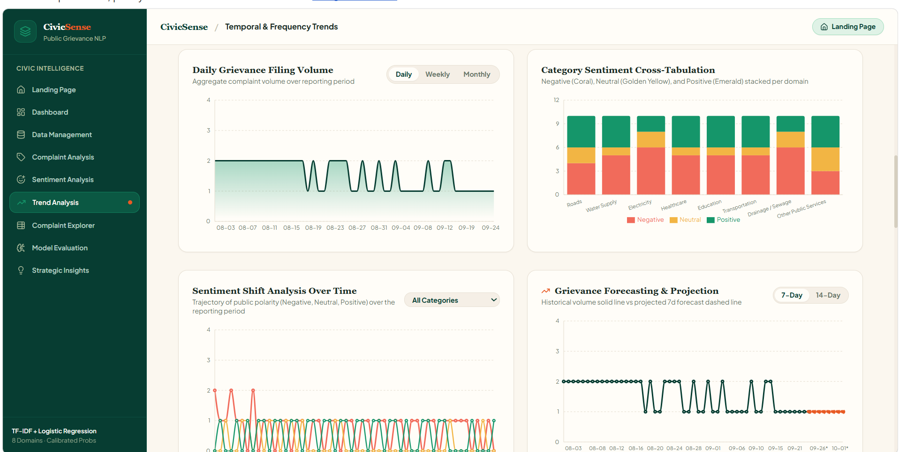

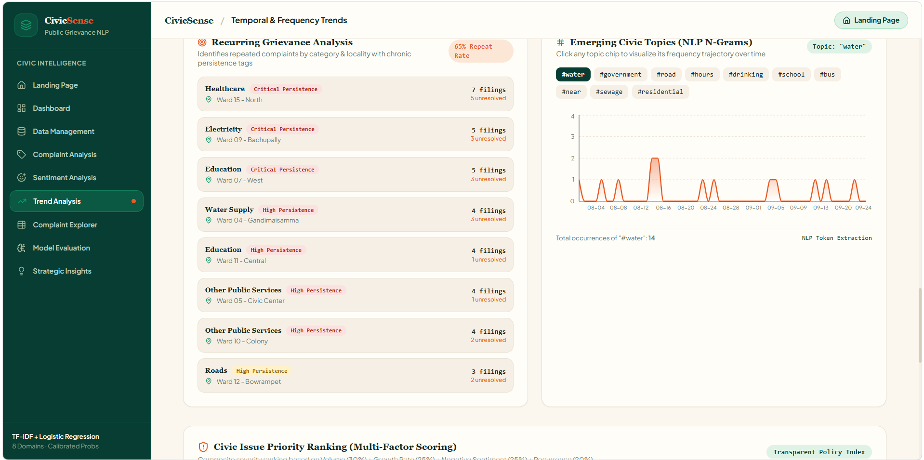

Acknowledgment
The authors would like to express their sincere gratitude to K L (Deemed to be) University, Department of Computer Science and Engineering, for providing the facilities and support required to complete the project titled “CivicSense: Public Grievance and Sentiment Analysis System.”
The authors sincerely thank Dr. N. Sunanda, project guide, for her valuable guidance, continuous support, and suggestions throughout the development of this project.
The authors also extend their thanks to the faculty members, friends, and everyone who provided support and encouragement during the successful completion of this project.

References
- [1] R. M. Rosa, J. D. de Souza, and C. do N. Freitas, “Development and deployment of sentiment analysis AI on citizens’ feedback in Goiás,” in Proc. 26th Annual International Conference on Digital Government Research (dg.o 2025), 2025, doi: 10.59490/dgo.2025.944.
- [2] M. Sarvestani, “An NLP-based framework for sentiment and topic analysis of citizen feedback on U.K. government mobile applications,” IEEE Access, vol. 13, pp. 210360–210377, 2025, doi: 10.1109/ACCESS.2025.3641669.
- [3] G. Salton and C. Buckley, “Term-weighting approaches in automatic text retrieval,” Information Processing & Management, vol. 24, no. 5, pp. 513–523, 1988, doi: 10.1016/0306-4573(88)90021-0.
- [4] F. Pedregosa et al., “Scikit-learn: Machine learning in Python,” Journal of Machine Learning Research, vol. 12, pp. 2825–2830, 2011.
- [5] Streamlit Inc., “Streamlit documentation.” [Online]. Available: https://docs.streamlit.io/
- [6] Scikit-learn developers, “Feature extraction of text data.” [Online]. Available: https://scikit-learn.org/stable/modules/feature_extraction.html

